M S Ramaiah Institute of Technology
(An Autonomous Institute, Affiliated to VTU)
MSR Nagar, MSRIT post, Bangalore-54
A Mid-Sem Evaluation Report on
Real time Response Capture and Analytics of
Tutoring Ecosystem
Submitted by
Ashwij S 1MS11CS152
Namratha Ravishankar 1MS11CS067
Nuthana kumari M 1MS12CS070
Aishwarya S S 1MS12CS142

Under the guidance of
Ganeshayya I Shidaganti
Asst.Professor
Computer Science
M S Ramaiah Institute of Technology


DEPARTMENT OF COMPUTER SCIENCE & ENGINEERING
M.S.RAMAIAH INSTITUTE OF TECHNOLOGY
(Autonomous Institute, Affiliated to VTU)
BANGALORE-560054
www.msrit.edu

Abstract:

Online learning has become a prominent and inseparable component of higher education in recent years. Questions related to course structure, levels of interaction, presence, and participation within online courses persist and invite further inquiry for determining factors that encourage effective teaching and learning in online environments.
Our Real time response capture and analytics system explores models of course development and delivery techniques to improve instruction, learning, and student satisfaction in online courses. Covering topics such as rates of participation, student engagement and retention, and social development, this system serves as a resource for educators in online learning environments, as well as for course designers and developers of online courses and researchers whose agenda includes examining interaction, presence, and participation in online courses.
.

Contents
Abstract …………………………………………………………………………………2
Project Synopsis…………………………………………………………………………4
Project Plan……………………………………………………………………………...7
SRS……………………………………………………………………………………...11
Literature Survey………………………………………………………………………..19
Design……………………………………………………………………………………23
References……………………………………………………………………………….32

Project Synopsis:
Existing System:
Feedback forms are used to collect the response of learners for online class. In this kind of works response for a session was collected at the end the session or video only. Received responses are analyzed to get the grade of that session.
Draw Backs:
Collecting feedback at the end of session will provide only overall performance. We are not able to get periodical response because of this educators are not able to understand which category of educating should be improved.
Proposed system:
In our work we are planned to capture the response at any time of the video session. We are going to provide the rating parameters such as Syllabus Coverage, Usage of Examples, Understandability and Practical Knowledge to learner for better response collection. N number of times learner can rate the performance of educator within the time of video session. By doing so, individual performance details of educator will be collected. At the end average of given ratings will be calculated. Total performance of the session will be analyzed with the help of ratings from all learners. This analysis will be given to educators to improve the performance in next sessions. Video wise comparison will be conducted by the admin person to verify the performances.

Project Objectives:
- Our main objective is to provide the rating parameters such as Syllabus Coverage, Usage of Examples, Understandability and Practical Knowledge to learner for better response collection. The learner can rate the performance of educator’s video session any number of times within the time limit.
- Total performance of the session will be analyzed with the help of ratings from all learners. This analysis will be given to educators to improve the performance in next sessions.
- Helps to improve learning, instruction and student satisfaction.

Advantages:

Performance of educator will be analyzed based on different parameters so that they can easily identify what type of inconvenience is faced by learners from them. They can easily rectify and improve the performances in next session. Performance analysis is given as graph to educators for easy understanding.

Work Flow:
Having a separate Login and Signup access for:

- Students (Signup having details of Name, Password, USN, Sem & Dept)
- Tutors (Signup having details of Name, Password, Faculty ID Number, Dept
- Admin (Signup having details of Name, Password, Admin ID Number, Designation)

Access Limitations to be:

- Students - Access Limited to Selection of Video/Classroom Session, Rating based on different parameters on the classroom sessions.
- Tutors - Access to Analyze their sessions (therefore few videos are to be pre assigned to the tutors, so that it restricts them from viewing other tutor's analysis)
- Admin - Access to analyze all individual sessions of tutors and also to compare the classroom sessions. The admin also should have a facility to save/send the graphs & csv files to files/emails.

Rating Parameter:

Rating to be made with several parameters like:
- Presentation Skills
- Syllabus Coverage
- Usage of Examples
- Understandability
- Practical Knowledge

Project Plan:
Effort estimation using COCOMO Constructive Model:

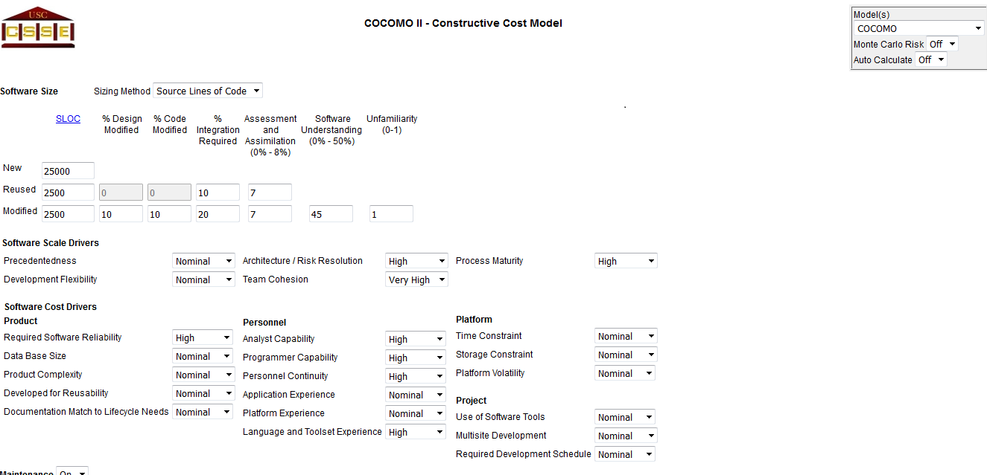

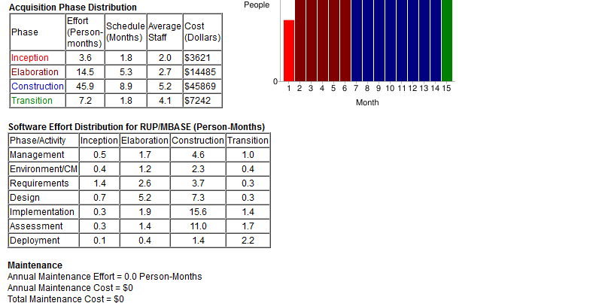

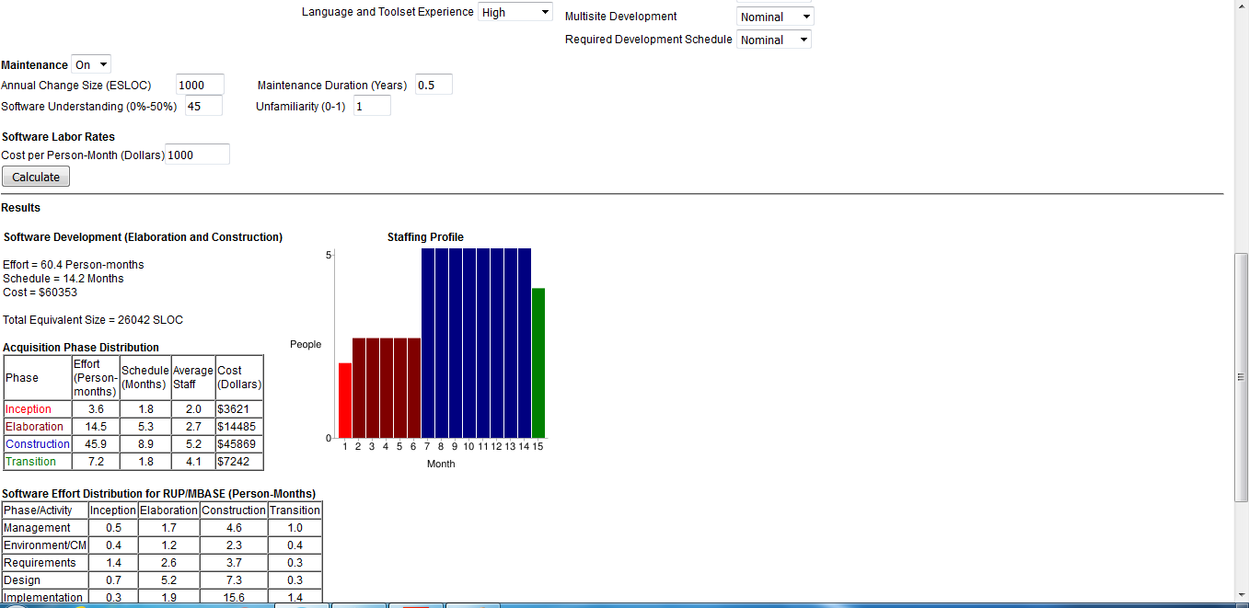

Project Activities:
GANTT CHART:

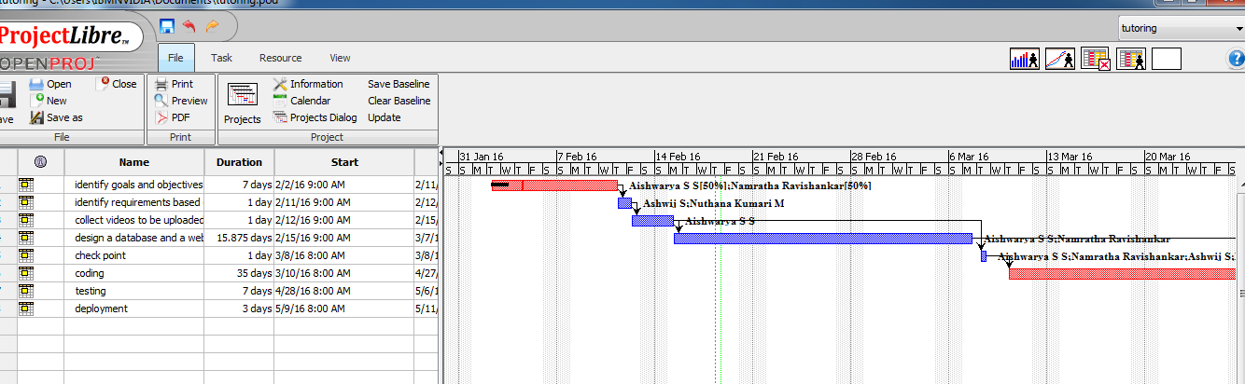

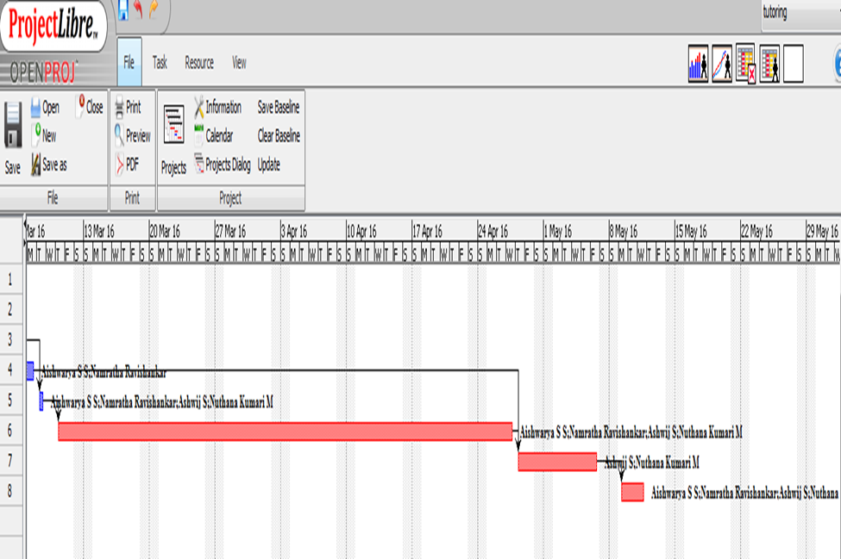

Risk Identification:

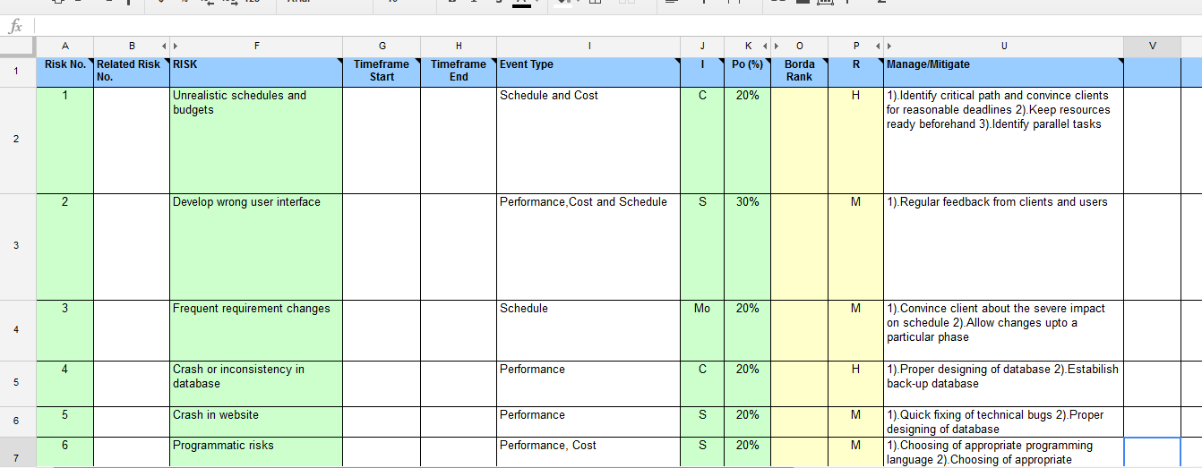

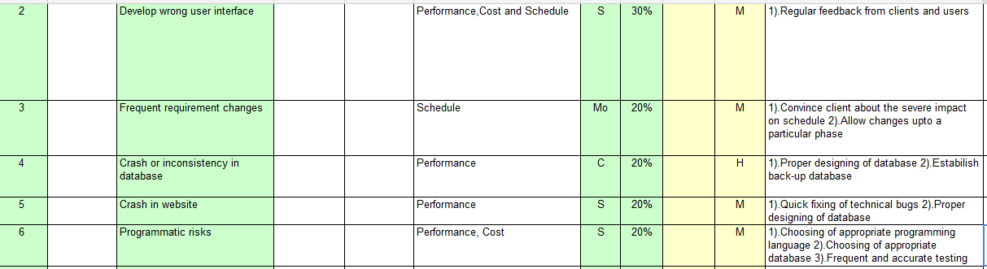

Software Requirements Specification:
External Interface Requirements
User Interfaces
- All the contents in the project are implemented using Graphical User Interface (GUI) in Java through JavaFX concepts.
- Every conceptual part of the projects is reflected using the JavaFX.
- System gets the input and delivers through the GUI
Hardware Interfaces
ISDN: We can connect AS/400 to an Integrated Services Digital Network (ISDN) for faster, more accurate data transmission. An ISDN is a public or private digital communications network that can support data, fax, image, and other services over the same physical interface. Also, you can use other protocols on ISDN, such as IDLC and X.25.
Software Interfaces: This software is interacted with the TCP/IP protocol, Socket and listening on unused ports. Server Socket and listening on unused ports and JDK 1.6. This software is also interacted with the SMTP protocol, sending and receiving on SMTP protocol.
Communication Interfaces
- TCP/IP protocol.
- SMTP.

Functional Requirements
An intelligent tutoring system is computer software designed to simulate a human tutor’s behavior and guidance. Because these systems are able to interpret complex student responses and can learn as they operate, they are able to discern where and why a student’s understanding has gone astray and to offer hints to help the student understand the material at hand. Intelligent tutors provide many of the benefits of a human tutor to very large numbers of students. Intelligent tutoring systems can also provide real-time data to instructors and developers looking to refine teaching methods.
User Classes and Characteristics
    - Student: when student views the video, gives comment and rating of that particular video
    - tutor: goes through the video analysis rating and comments

Software System Attributes
Reliability

Reliability ensures the integrity and consistency of the application and all its transactions. As the load increases on your system, your system must continue to process requests and handle transactions as accurately as it did before the load increased. Reliability can have a negative impact on scalability. If the system cannot maintain the reliability as the load increases, then the system is really not scalable. So, for a system to truly scale it must be reliable.
Availability
Availability ensures that a service/resource is always accessible. Reliability can contribute to availability, but availability can be achieved even if components fail. By setting up an environment of redundant components and failover, an individual component can fail and have a negative impact on reliability, but the service is still available due to the redundancy.
Security
Security is the ability to ensure that the system cannot be compromised. Security is by far the most difficult systemic quality to address. Security includes not only issues of confidentiality and integrity, but also relates to Denial-of-Service (DoS) attacks that impact availability. Creating an architecture that is separated into functional components makes it easier to secure the system because you can build security zones around the components. If a component is compromised, then it is easier to contain the security violation to that component.

Portability

This software will be designed to run on windows OS and forward compatibility

Maintainability

Maintainability is the ability to correct flaws in the existing functionality without impacting other components of the system. This is another of those systemic qualities that you cannot measure at the time of deployment. When creating an architecture and design, you should consider the following to enhance the maintainability of a system: low coupling, modularity, and documentation.

Performance

The performance requirement is usually measured in terms of response time for a given screen transaction per user. In addition to response time, performance can also be measured in transaction throughput, which is the number of transactions in a given time period, usually one second. For example, you could have a performance measurement that could be no more than three seconds for each screen form or a transaction throughput of one hundred transactions in one second. Regardless of the measurement, you need to create an architecture that allows the designers and developers to complete the system without considering the performance measurement.
Performance Requirements

In WMNs, network-layer handoff signalling packets, including the signalling messages for obtaining a new IP address for the MC (e.g., Agent Solicitation, Agent Advertisement), finding a new route to the new gateway, and updating the new IP address, may be transmitted over the multi-hop wireless mesh backbone with data packets on the same backhaul channel in traditional designs. In this scenario, signalling packets compete with data packets for the same wireless resources. Therefore, the more data packets are generated in the mesh backbone, the more possible collisions may occur between the two types of packets, which results in long handoff delay. In addition, the contention of the two types of packets on the same channel increases the end to end (ETE) delay of both packets.
Database Requirement

Oracle
An Oracle database is a collection of data treated as a unit. The purpose of a database is to store and retrieve related information. A database server is the key to solving the problems of information management. In general, a server reliably manages a large amount of data in a multiuser environment so that many users can concurrently access the same data. All this is accomplished while delivering high performance. A database server also prevents unauthorized access and provides efficient solutions for failure recovery.
Oracle Database is the first database designed for enterprise grid computing, the most flexible and cost effective way to manage information and applications. Enterprise grid computing creates large pools of industry-standard, modular storage and servers. With this architecture, each new system can be rapidly provisioned from the pool of components. There is no need for peak workloads, because capacity can be easily added or reallocated from the resource pools as needed.
The database has logical structures and physical structures. Because the physical and logical structures are separate, the physical storage of data can be managed without affecting the access to logical storage structures

Database design
A database is usually a fundamental component of the information system, especially in business oriented systems. Thus database design is part of system development. The following picture shows how database design is involved in the system development lifecycle.
The phases in the middle of the picture (Database Design, Database Implementation) are the phases that you concentrate on in the Database Design course. The other phases are briefly described. They are part of the contents of the Systems Analysis and Design courses, for example.
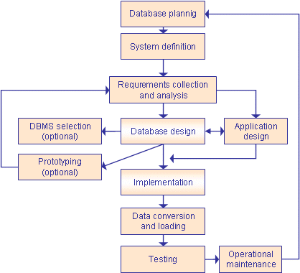

Database Planning
The database planning includes the activities that allow the stages of the database system development lifecycle to be realized as efficiently and effectively as possible. This phase must be integrated with the overall Information System strategy of the organization.
The very first step in database planning is to define the mission statement and objectives for the database system. That is the definition of
- the major aims of the database system
- the purpose of the database system
- the supported tasks of the database system
- the resources of the database system
Systems Definition
In the systems definition phase, the scope and boundaries of the database application are described. This description includes:
- links with the other information systems of the organization
- what the planned system is going to do now and in the future
- who the users are now and in the future.
The major user views are also described. i.e., what is required of a database system from the perspectives of particular job roles or enterprise application areas.

Requirements Collection and Analysis
During the requirements collection and analysis phase, the collection and analysis of the information about the part of the enterprise to be served by the database are completed. The results may include e.g.:
- the description of the data used or generated
- the details how the data is to be used or generated
- any additional requirements for the new database system

Database Design
The database design phase is divided into three steps:
- conceptual database design
- logical database design
- physical database design
In the conceptual database design phase, the model of the data to be used independent of all physical considerations is to be constructed. The model is based on the requirements specification of the system.
In the logical database design phase, the model of the data to be used is based on a specific data model, but independent of a particular database management system is constructed. This is based on the target data model for the database e.g. relational data model.
In the physical database design phase, the description of the implementation of the database on secondary storage is created. The base relations, indexes, integrity constraints, security, etc. are defined using the SQL language.

Database Management System Selection
This in an optional phase. When there is a need for a new database management system (DBMS), this phase is done. DBMS means a database system like Access, SQL Server, MySQL, Oracle.
In this phase the criteria for the new DBMS are defined. Then several products are evaluated according to the criteria. Finally the recommendation for the selection is decided.

Application Design
In the application design phase, the design of the user interface and the application programs that use and process the database are defined and designed.

Protyping
The purpose of a prototype is to allow the users to use the prototype to identify the features of the system using the computer.
There are horizontal and vertical prototypes. A horizontal prototype has many features (e.g. user interfaces) but they are not working. A vertical prototype has very few features but they are working. See the following picture.
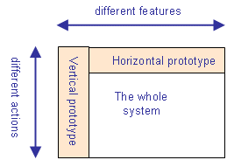

Implementation
During the implementation phase, the physical realization of the database and application designs are to be done. This is the programming phase of the systems development.

Data Conversion and Loading
This phase is needed when a new database is replacing an old system. During this phase the existing data will be transferred into the new database.

Testing
Before the new system is going live, it should be thoroughly tested. The goal of testing is to find errors! The goal is not to prove the software is working well.

Operational Maintenance
The operational maintenance is the process of monitoring and maintaining the database system. Monitoring means that the performance of the system is observed. If the performance of the system falls below an acceptable level, tuning or reorganization of the database may be required. Maintaining and upgrading the database system means that, when new requirements arise, the new development lifecycle will be done.
Design and Implementation Constraints

Constraints in Analysis
- Constraints as Informal Text
- Constraints as Operational Restrictions
- Constraints Integrated in Existing Model Concepts
- Constraints as a Separate Concept
- Constraints Implied by the Model Structure

Constraints in Design
- Determination of the Involved Classes
- Determination of the Involved Objects
- Determination of the Involved Actions
- Determination of the Require Clauses
- Global actions and Constraint Realization

Constraints in Implementation
A hierarchical structuring of relations may result in more classes and a more complicated structure to implement. Therefore it is advisable to transform the hierarchical relation structure to a simpler structure such as a classical flat one. It is rather straightforward to transform the developed hierarchical model into a bipartite, flat model, consisting of classes on the one hand and flat relations on the other. Flat relations are preferred at the design level for reasons of simplicity and implementation ease. There is no identity or functionality associated with a flat relation. A flat relation corresponds with the relation concept of entity-relationship modeling and many object oriented methods.

Other Requirements
Safety Requirements

- The software may be safety-critical. If so, there are issues associated with its integrity level
- The software may not be safety-critical, although it forms part of a safety-critical system. For example, software may simply log transactions.
- If a system must be of a high integrity level and if the software is shown to be of that integrity level, then the hardware must be at least of the same integrity level.
- There is little point in producing 'perfect' code in some language if hardware and system software (in widest sense) are not reliable.
- If a computer system is to run software of a high integrity level then that system should not at the same time accommodate software of a lower integrity level.
- Systems with different requirements for safety levels must be separated. Otherwise, the highest level of integrity required must be applied to all systems in the same environment.

Literature Survey
Introduction:
Data mining, the extraction of hidden predictive information from large databases, is a powerful new technology with great potential to help companies focus on the most important information in their data warehouses. Data mining tools predict future trends and behaviors, allowing businesses to make proactive, knowledge-driven decisions. The automated, prospective analyses offered by data mining move beyond the analyses of past events provided by retrospective tools typical of decision support systems. Data mining tools can answer business questions that traditionally were too time consuming to resolve. They scour databases for hidden patterns, finding predictive information that experts may miss because it lies outside their expectations.
Data mining techniques are the result of a long process of research and product development. This evolution began when business data was first stored on computers, continued with improvements in data access, and more recently, generated technologies that allow users to navigate through their data in real time. Data mining takes this evolutionary process beyond retrospective data access and navigation to prospective and proactive information delivery
We are in an age often referred to as the information age. In this information age, because we believe that information leads to power and success, and thanks to sophisticated technologies such as computers, satellites, etc., we have been collecting tremendous amounts of information. Initially, with the advent of computers and means for mass digital storage, we started collecting and storing all sorts of data, counting on the power of computers to help sort through this amalgam of information. Unfortunately, these massive collections of data stored on disparate structures very rapidly became overwhelming. This initial chaos has led to the creation of structured databases and database management systems (DBMS).
The efficient database management systems have been very important assets for management of a large corpus of data and especially for effective and efficient retrieval of particular information from a large collection whenever needed. The proliferation of database management systems has also contributed to recent massive gathering of all sorts of information. Today, we have far more information than we can handle: from business transactions and scientific data, to satellite pictures, text reports and military intelligence.
Information retrieval is simply not enough anymore for decision-making. Confronted with huge collections of data, we have now created new needs to help us make better managerial choices. These needs are automatic summarization of data, extraction of the "essence" of information stored, and the discovery of patterns in raw data.
Main Body:
Online Tutoring:
Online tutoring is the process of tutoring in an online, virtual environment or networked environment in which teachers and learners are separated by time and space. Online tutoring, as a reflection of the diversity of the wider Internet, is practiced using many different approaches and is addressed to distinct sets of users. The distinctions are in online content and interface, as well as in tutoring and tutor-training methodologies. Definitions associated with online tutoring vary widely, reflecting the ongoing evolution of the technology, the refinement and variation in online learning methodology, and the interactions of the organizations that deliver online tutoring services with the institutions, individuals, and learners that employ the services.
The practice of online tutoring
Differences between online and face-to-face tutoring
In both online and face-to-face tutoring, similarities lie in the areas of group dynamics, need for roles within the group and design to encourage in-group interaction. Differences include the need for more facilitation to help structure discussions, with group roles emerging more slowly in the online setting.
Tactical online tutoring
Tactical tutors are expected to display sensitivity to group interactions and progress, or the lack thereof, and to respond within an online interaction at critical moments in which their mastery of the subject and ability to explain it is requested by the learner or in which the learner makes manifest errors. They are more likely than strategic tutors to be employed in one-on-one interfaces. Asynchronous tutoring allows a tutor to convey insight into strengths and weaknesses of a learner's work.
Private online tutoring services
In general, academic online tutors are available through various virtual learning environments to help learners answer questions on specific subject matter, to help in the writing of essays, and to assist with research. Offerings vary from sites loosely associated with campuses, to sites directly contracted by and operating in concert with educational institutions, textbook publishers, or libraries. Access to the publisher or campus-provided online tutoring may be limited to just a few hours.
Other major concerns of parents or teachers in making use of online tutoring services include:
- The perceived indifference of an online tutor to a learner's developmental issues that reach beyond a single session.
- Cultural communication difficulties that might arise between remote tutors and a local learner. And
- Doubts as to the academic qualifications of the online tutor, even if certified by a corporation.
Strategic online tutoring
Strategic tutors do more prior planning, including determining the number of learners per group and membership. Smaller groups are more likely to cultivate trust, whereas a larger group provides for greater heterogeneity and promotes interaction and For strategic online tutoring, full participation depends upon robust connectivity and efficient use of bandwidth to guarantee full participation.
Design for group learning
The prior design of online activities is one aspect of strategic tutoring. They promote peer group learning and result in less online tutoring time. It has following characteristics:
- They can optimize student engagement if they are authentic and relevant learning activities.
- They can take any form of structured participative group work online.
- They are based on one key topic or question to make online e-moderating easy and to provide motivation.

System Design
Number of Modules
We have 5 modules:
- Registrations
- Login
- Video uploading
- Rating
- Performance analysis

Modules description
Registrations: User Registration (PUR) module allows users to register and access restricted content. You can use the module to register users for the Forum module and other custom modules that support personalization and user specific handling. For example, collect e-mail addresses of subscribers to a newsletter and allow them to manage subscription details after login
Login: After registration all users will get a username and password. After login, server or admin will check the user entered username and password and compare to the database. If it is correct allow access to the next page else drop that request.
Video uploading: When staff wants to upload the video, the admin will check for the staff’s authentication and credential details. If it’s true then allow staff to upload the video. After uploading admin can publish video to student
Rating: After watching the video students will be able to give a feedback based on different criteria such as:
- Presentation Skills
- Syllabus Coverage
- Usage of Examples
- Understandability
- Practical Knowledge

Performance analysis: Access to analyze all individual sessions of tutors and also to compare the classroom sessions. The admins also should have a facility to save/send the graphs & csv files to files/emails.
Algorithm:
Admin Role:
Step 1: Registration of students by giving the details like student name, semester and year of studying
Step2: Once the students have registered they will get a login credential from admin
Step 3: Register the tutor’s with their personal details and provide login credential to each tutor
Step 4: Allocate the videos to each tutor in day basis
Step 5: Overall performance of the tutor and video wise performance are analyzed by the admin in the analyze session with the help of ratings given to different parameters such as Presentation skill, Practical Knowledge, Syllabus Coverage, Understandability, Usage of Examples
Step 6: comparison of video’s performance and staff performance is done by admin with the help of above said parameters
Step 7: Admin will send these performance reports to the Head of the institution through mail

Staff Role:
Step 1: Staff can analyze the rating points to improve their performance in their next session
Step 2: To better understanding staff can view their performance in video-wise method and over all method
Step 3: Ratings will be given at different times by the students. So to identify the proper result in this rating scheme aggregation and average calculation on rating points will be done by admin. Overall performance will be identified by taking average of given ratings to different parameters

Student Role:
Step 1: Students have to login with the given login credential
Step 2: Students have to select the video session based on the day
Step 3: From the available sessions, students have to pick any one session
Step 4: selected session will be playing with the help of media player on web page
Step 5: students have to give rating points based on the performance of the tutor on video
Step 6: students can give rating at any point of video
Step 7: at the end of the session students have to give their feedback on the video that they watched. At the same time they can view feedback of other students in the comment area.

2. Architecture Design

Student
Staff
Registration
login

List of allotted videos
Watch video
Give rating for full video
Performance Analysis
Admin
Assign videos to staff
Comparison of result
login

Get staff performance

Graphical User Interface
User Interfaces
- All the contents in the project are implemented using Graphical User Interface (GUI) in Java through JavaFX concepts.
- Every conceptual part of the projects is reflected using the JavaFX.
- System gets the input and delivers through the GUI
Hardware Interfaces
ISDN: We can connect AS/400 to an Integrated Services Digital Network (ISDN) for faster, more accurate data transmission. An ISDN is a public or private digital communications network that can support data, fax, image, and other services over the same physical interface. Also, you can use other protocols on ISDN, such as IDLC and X.25.
Software Interfaces
This software is interacted with the TCP/IP protocol, Socket and listening on unused ports. Server Socket and listening on unused ports and JDK 1.6. This software is also interacted with the SMTP protocol, sending and receiving on SMTP protocol.
Communication Interfaces
- TCP/IP protocol.
- SMTP.

Class Diagram and Classes

student
Id, password, emailid, ph.no
,first-name, last-name
Registration
Login
Watch video
Rating
Comments
Presentation skills
Syllabus coverage
Understandability
Practical knowledge
Usage of examples

staff
Id, password, emailid, ph.no
,first-name, last-name
Registration
Login
Watch video
Video to video comparison

admin
Username
password
login
Get all staff performance
Compare performance of -various staff
Send email to staff

Sequence Diagram

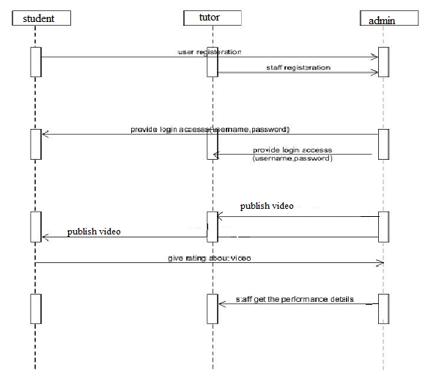

Data flow diagram

Student module
Student
Log in
Selection of day
Watching video
Rating the session
Feedback submissionnnnnnn

Staff module

Staff
Log in
Select analyzing method
Selection of parameter
Viewing performance in graph

Admin module
Video wise or overall
Admin
Log in
Select analyzing method
Selection of parameter
Viewing performance in graph
Selection of videos/staff to compare
Comparison
Reporting performance to head

Conclusion
Collecting feedback at the end of session will provide only overall performance. We are not able to get periodical response because of this educators are not able to understand which category of educating should be improved. Our main objective is to provide the rating parameters such as Syllabus Coverage, Usage of Examples, Understandability and Practical Knowledge to learner for better response collection. The learner can rate the performance of educator’s video session any number of times within the time limit. Total performance of the session will be analyzed with the help of ratings from all learners. This analysis will be given to educators to improve the performance in next sessions. Helps to improve learning, instruction and student satisfaction.

References
- https://net.educause.edu/ir/library/pdf/ELI7098.pdf
- http://www.ccdmd.qc.ca/eng/catalog/online-tutoring-system-otsew
- https://courses.edx.org/courses/course-v1:Microsoft+DAT204x+3T2015/courseware/0e22dfa93698465e85578dfe54d5726e/38b14f822002414d864ecfc4f85460d5/

